Preferential treatment in Renewable Energy Auctions: An analysis of the reference yield model & German wind auctions

Prokop Čech ORCID iD: 0000-0002-4233-8726

University J. E. Purkyně (FSE-UJEP) (Ústí nad Labem, The Czech Republic)

[prokop.cech@ujep.cz](mailto:prokop.cech@ujep.cz)

Abstract

Procurement auctions are increasingly used to allocate and set the level of support in the form of subsidies for new renewable energy sources. I analyse an auction design that adjusts the competitive conditions for bidders to compensate for differences in their sites’ qualities, **“the reference yield model”**. Such an auction design is used for onshore wind auctions in Germany.

Using auction theory and stochastic simulations, I analyse the impact of the reference yield model on cost efficiency. I show that, **in weakly competitive auctions, the reference yield model decreases the bidders’ profits and the subsidies**. Calibrating the model to data from German onshore wind auctions, I find that, in weakly competitive auctions, the reference yield model decreases the subsidies up to 22 EUR/MWh. In strongly competitive auctions, it increased the subsidies, but by less than 1 EUR/MWh. As the German wind auctions were mostly undersubscribed and thus weakly competitive, the net effect was decreasing.

Keywords: renewable energy auctions, reference yield, Monte Carlo simulation, German wind auctions

Funding: This research was funded from internal grant (SGS) of the Jan Evangelista Purkyně University, project number: *UJEP-SGS-2021-45-001-2*, name of the project: *Preferenční zacházení s projekty v aukcích obnovitelných zdrojů*

Code availability: The model used in this research (custom code based on Python 3.8.3) and the complete set of generated data can be downloaded from https://github.com/alotbsol/Auctions---Reference-yield.

Contents

1. Introduction 3

2. Renewable energy auctions 4

2.1. Literature 4

2.2. Auction design 5

3. Reference yield model 5

3.1. How it works 7

3.2. Effect of RYM 7

4. Assumptions and distributions 8

4.1. Assumptions 8

4.2. Inputs and distribution 9

4.3. Derived parameters 11

4.4. Summary of inputs 14

5. Model calculation 15

5.1. Project surplus 15

5.2. Subsidy 15

5.3. Auction result 16

5.4. General assumptions and implications 17

6. The model – simple case 17

6.1. Simple case - no reference yield model 17

6.2. Simple case - reference yield model 18

6.3. Other costs 20

7. The model – typified distribution of supply 22

7.1. Typified distributions 22

7.2. Impact of RYM 23

8. The model - German wind auctions 25

8.1. Distribution of wind speeds in Germany 25

8.2. Overview of auctions - demand/supply - 27

8.3. Subscribed auctions 27

8.4. Under-subscribed auctions 29

8.5. Summary of German auctions 30

8.6. Assumptions and limitations 31

9. Conclusion 31

A. Technical assumptions regarding wind production 36

B. Full results of different distributions of supply based on typified conditions (Section 7) 37

# Introduction

Auctions are increasingly becoming the new standard for determination of level of support for renewable energy sources, however different countries are using different auction design frameworks. Economic research on auctions has brought a vast body of evidence that auctions are an efficient and effective method to allocate scarce goods (Klemperer, 2002). However, the international experience with auctions has not resulted in a solid track record, with examples of successes and failures. Del Río & Linares (2014) and Klemperer (2002) argue that many auctions have not been successful because they had not been well-designed. As shown by several studies relatively small changes in specific design elements can have significant impact on results (Del Río & Linares, 2014, Binmore & Klemperer, 2002; Klemperer, 2002). Usually mainly allocative and cost efficiency is being discussed, i.e., which projects will be built and how much it will cost.

This paper addresses specific auction design element, **the reference yield model** (“RYM”), which is being used for wind auctions in Germany, where competitors bid based on standardized wind conditions. The RYM is analogically similar to price preference policy, i.e., it does not necessarily choose the lowest bidder but rather treats each bid differently based on set conditions. The regulator aims to give equivalent competitive conditions for project with different wind potential, allowing competition between windy north of the country and less windy south (BMWi, 2016). Relatively underexplored design element which have the potential of changing the behaviour in auctions as well as development of new projects in general. As the RYM compensates projects with different wind conditions differently, it is changing the underlying value of projects going to auctions. The preferential treatment of the RYM may lead to different optimal bidding strategy, different projects chosen in the auctions and therefore also different cumulative electricity output of chosen projects.

Auction theory has provided a theoretical basis for the RYM a long time ago, with the **analysis of the price preference policy**. McAfee & McMillan (1989) shows for a very specific scenario (including two categories of bidders and a single unit for sale) that a price preference policy has a strategic effect that can lead to a lower expected price for the regulator. Further, experiments by Corns & Schotter (1999) and Shachat & Swarthout (2010) support the thesis that price preference policy, if rightly chosen, can be cost-effective for specific scenarios. Their experiments however do not address the central questions of cost and efficiency of design in relation to renewable energy-specific auction design (and specific application of the RYM).

Several studies have been performed to explore the design elements applied in the case of German renewable auctions. Bade et al. (2015) or Klessmann et al. (2015) provide a detailed overview of German auction design, however, they do not provide a rigorous economic model that addresses the central questions. Luck & Moser (2018) present a machine learning model for wind turbine allocation under German regulatory conditions, considering the allocative efficiency of the RYM. Anatolitis & Welisch (2017) present multiple agent models for German onshore wind auctions, taking into account the RYM, in order to compare uniform and pay-as-bid auction format. However, Luck & Moser (2018) and Anatolitis & Welisch (2017) do not address cost-efficiency issues and also do not take into account the strategic effect uncovered in McAfee & McMillan (1989). Bichler et al. (2019) analyse possible German wind auction designs and conclude that the national RYM yields a higher allocative efficiency, but at the expense of a higher average remuneration per kWh. However, Bircher et al. (2019) also do not take into account the strategic effect.

Based on the German specific design element I derive a more general approach and address the impact of preferential treatment in Renewable Energy Auctions in order to answer the central question: **does the reference yield model increase or decrease the cost efficiency of renewable energy auctions and what are the main drivers for the effect?**

The paper firstly introduces the renewable energy auctions. Further, it describes the RYM which is used for German wind auctions and mathematical representation is introduced. Based on the possible input parameters a theoretical stochastic model is described and subsequently its results discussed under various typified conditions. Further, specific case study of past German wind auctions is presented, and possible impact of RYM calculated, followed by the conclusion.

# Renewable energy auctions

Through auctions one or several goods are allocated and priced based on submitted bids. Arguments in favour of auctions (procurement) are competitive price determination, minimized procurement costs, and efficient allocation (Krishna, 2010). For general overview of auction theory interested readers are directed to e.g., Klemperer (1999, 2004), Cramton (2009), Menezes & Monteiro (2005), and Milgron (2004).

Renewable energy auctions are on the rise since 90´s, when they were first introduced (Kitzing et al., 2012). Since then, most EU states have either already implemented or are planning to implement renewable energy auctions (CEER, 2018). Based on the EU Guidelines, the regulation should limit the aid to the minimum level necessary and currently the prevalent approach is to compete in tenders (European Comission, 2014).

Whether the auction will be successful depends largely on the auction design. There is no one size fits all solution and specific design elements usually come with trade-offs between different goals of regulation and as such a suitable regulatory framework will always depend on the priority of the regulator.

# Literature

Many studies have been performed in order to address specific renewable energy auction design elements and their possible impact, such as volume, periodicity, diversity, participation conditions, support cost conditions, selection criteria, auction format, auction type, pricing rules, realization periods and penalties (Del Río, 2017). For further analyses of renewable energy auctions and specific design elements, see e.g.: Del Río & Linares, (2014), Ehrhart et al., (2015), Gephart et al. (2017), Haufe & Ehrhart (2018), or Kreiss et al., (2017).

For the purpose of studying specific design elements in complex energy environment with significant number of variables analytical solutions are often not available. Variants of computational modelling are often used instead. By studying complex system with computer simulations one can experiment with the parameters and observe outcomes without having to solve the mathematical models. Among such approaches many cases can be studied, such as study on allocating renewable subsidies studied on Hungarian solar auctions by Hortay, (2019), system-optimal distribution of generation capacity by Bichler et al., (2019), auction design in relation to prequalifications and penalties by Kreiss et al. (2017), quantification of location-based investment incentives by Piel et al. (2017), strategic bidding optimization by Stetter et al., (2019), demand reduction analysis by Ausubel et al., (2014), model of RES auctions as bidding for real options elaborating on truthful bidding by Matthäus et al., (2019) and many others.

Further several types of “learning agent” models have been also used for studying renewable energy auctions. Such systems try to mimic incomplete information of agents and their subsequent interaction, such as simulating market-based policies for RES using learning agents by Fagiani, & Hakvoort, (2014), predicting simultaneous operations and interactions of multiple agents for onshore wind auctions in Germany by Anatolitis & Welisch, (2017), or machine learning model for wind turbine allocation by Luck & Moser, (2018).

# Auction design

Typically, renewable energy auctions are conducted as reversed sealed bid first price auctions, i.e., procurement auctions paid as bid. In procurement auctions the auctioneer is the buyer and the bidder act as a seller and offer goods (capacity or energy produced) to the auctioneer. In paid as bid auctions, The regulator buys from the bidders offering the best bid (such as the lowest price). The volume to be auctioned (in various units) is predetermined by the regulator and winners receive the price that they have offered in the competitive tender.[1]

A Substantive amount of literature has been written on the comparison of first and second bid pricing rules (discriminatory and uniform pricing) with the conclusion that the difference usually depends on the specific conditions of an auction (Fabra et al., 2006). For specific analysis of different revenue expectation for German onshore wind auctions Anatolitis & Welisch (2017) provide a detailed analysis.

Further, majority of the RES auctions are multi-unit auctions (Haufe, Ehrhart, 2018)[2] and only multi-unit auctions with homogeneous units are discussed within the scope of this paper.[3]

# Reference yield model

Germany introduced a unique design element in wind auction, the so-called reference yield model, which compensates projects differently based on their production potential (“Renewable Energy Sources Act” (EEG) 2017). Projects which are disadvantaged by their production potential (e.g., projects on less windy south of Germany), receive higher remuneration compared to projects with higher potential (e.g., on windy north of Germany), given that both submit identical bids in the auctions. That means that bids which are submitted to the auctions are after evaluation and determination of winning projects subsequently adjusted by a correction factor i.e., projects receive different remuneration than submitted into auctions.

The production potential is mainly determined by the wind speed at given site. Other parameters which can influence the production (e.g., technology selection, altitude, wind profile etc.) are further referred to as other production parameters. Wind speed and other production parameters are further cumulatively referred to as “production potential”.

The correction factor decreases differences between projects and influence expected profitability. However, the production potential is not the only determinant of the expected project profitability, as many other factors such as construction costs, development cost, operating expenditures etc., may also play a significant role. All other parameters are further referred to as “other costs”.

Figure 1 below shows, for illustrative purposes only, 3 scenarios of a correction mechanism and its impact on profitability based on production potential. In the first scenario no correction is applied, and higher production potential yields higher profitability. In the second scenario, profitability of high production potential projects is decreased and conversely profitability of low production potential sites is increased. The third scenario shows overcorrection, where low production potential sites are more profitable than high ones. Project profitability is based on the production potential (show as linear function in the picture) and other costs, which can either increase or decrease the profitability of a specific project. A Similar figure was used byBade et al., (2015).

Figure 1; Possible impact of reference yield model on profitability of projects, given similar bids in auctions

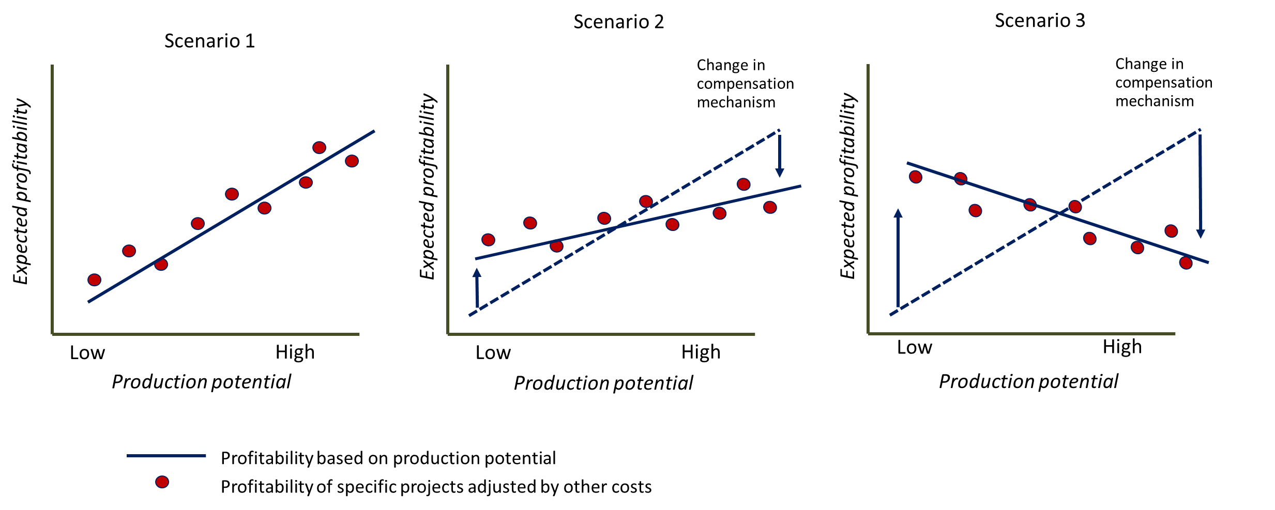

Such correction is not completely new to the German regulatory framework, as under previous version of EEG (2012) **correction to amount of subsidy received (feed in tariff) was also applied based on the production of specific wind farm**. Similar FIT adjustments can also be found e.g., in France and to certain extant also Netherlands. However, translation of such mechanism also to the auction environment is specific for German wind auctions.

According to the Federal ministry for Economic Affairs and Energy, **such mechanism was introduced in order to build efficient installations at less windy sites by putting equivalent competitive conditions for funding in places with different wind conditions**. Also considering that subsequent transmission of electricity brings additional costs as well as technical difficulties. (BMWi, 2016)

As projects with worse production potential gets prioritized over some of the projects with higher wind speed, one may argue that such a mechanism **decreases allocative efficiency** (as projects with higher costs can be chosen)**.** On the other hand, one may also argue vice versa in specific cases as **more spatially balanced expansion** of renewable energy and lower system cost (e.g., for transmission) can be achieved (Anatolitis & Welisch, 2017). For more details on this topic Klessmann et al. (2015) or Badeet al. (2015) is recommended.

The reference yield mechanism fundamentally changes the principle of competition in auctions. Usually, it is mainly the production potential which is the determinant of difference between projects going into the auctions. Thus, the projects with the highest production potential should usually yield higher profitability. When such projects compete in competitive tenders it naturally doesn’t have to “compete hard”. Such project has higher potential to capture additional value in the auctions.

# How it works

Based on technical parameters a “site quality” is assigned to each project and further correction factor ranging from, 0,79 to 1,29 is applied to a bid which was submitted to auction. The function is depicted in Figure 2.

Figure 2; function of site quality and correction factor

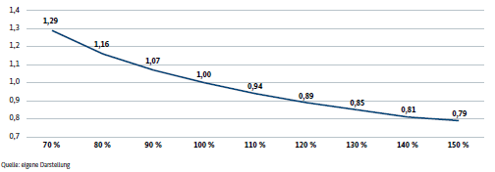

Source: BMWi, 2016

The correction factor tries to minimize the difference between projects based on different production potential as every project would be competing in the same location, however simple function which would link the wind speed and other technical parameters at given place and the associated costs for the project construction and operation does not exist. Should the reference yield model be set precisely, the difference between projects and thus potential advantage and disadvantage in auctions, would then be determined by all other influences besides production potential.

# Effect of RYM

An auction outcome is considered allocative efficient if no ex-post incentives for resale exist (Ausubel and Cramton et al., 1998). This condition is not influenced by the reference yield model. The correction factor will be applied disregarded of the owner of the project, i.e., the correction factor is based on specific location of the project. However, the allocation efficiency in terms of whether the “best” projects will be built (both in terms of projects with lowest levelized cost of energy and cheapest for the system to integrate) will depend on the set up of the correction factor. As mentioned above, “ideal” correction factor can hardly be set, as the optimal allocative outcome is not just function of wind speed or production potential but rather a complex set of inputs.

Several studies have been performed in order to assess allocative efficiency of reference yield model, Bichler et al. (2019) concludes that the national reference yield model yields a higher allocative efficiency at the expense of a higher average remuneration per kWh. It is to be noted that higher remuneration per kWh due to reference yield model is further questioned in this paper, at least under some assumptions. For further analysis, please also see e.g., Luck & Moser (2018).

Besides allocation effects, the reference yield model can also change the behaviour and strategy of bidders as the minimum bid each bidder can profitably submit in auctions is changed. The reference yield model can thus also significantly influence the remuneration that the regulator compensates, both because bidders behave differently, and the correction factor is applied on top of submitted bids and because of different projects that may end up being selected.

# Assumptions and distributions

In this section I introduce the assumptions of the model. Further I discuss respective inputs and limits for their distribution. From these inputs I show the calculation of derived parameters.

# Assumptions

Three main simplifications are considered within the model: independent private values, uniform pricing and one project per bidder. The model thus assumes that bidding one´s cost (i.e., minimum bid) in a multi-unit auction with uniform pricing, when the bidder submits bid for only one unit, is a weakly dominant strategy (Milgrom, 2004).

Independent private values

I assume that independent private values hold in the renewable energy auctions, i.e., each bidder has drawn its private value (valuation only known to him) from the same probability distribution and this distribution is known for all bidders prior to the auction.[4] Such assumption is often used, see e.g., Haufe & Ehrhart (2018) and specifically for German wind also supported by Wallasch and Luers, (2013).

The distribution of the production potential is fairly predictable. Bidders should know their project well (how much electricity it should produce if it is realized). Even free websites provide a rough calculation of the expected production based on geographical location and technology selection[5]. Although such a simple analysis cannot substitute a proper evaluation, on average it should provide fairly reasonable prediction and also allows bidders to study other potential projects on the market. Therefore, the probability distribution of projects entering the auctions can be estimated with reasonable precision. Also, the regulator should thus have a general estimation of what the inherit differences between projects are (how much more electricity will be made on the best possible locations compared to less suitable ones).

Other costs are predictable to a lesser extent and their distribution does not necessarily need to correlate with production potential. Nevertheless, certain knowledge of boundaries and distributions can be assumed for bidders operating within the RES market.

Uniform pricing

Renewable energy auctions are typically conducted as multi-unit first price sealed bid auctions. To analyse the impact of the RYM, **uniform pricing (second price)** is used instead of discriminatory pricing (first price). Although discriminatory pricing is mostly used in practice (as well as in German wind auctions). Uniform pricing can serve as a simple benchmark in the analysis, as only bidder´s costs and potentially correction factor is determinant for the bidding strategy (and both are known within the model).[6]

It is important to note that as Anatolitis & Welisch, (2017) show, that under discriminatory pricing (pay as bid) average bids should be lower compared to uniform pricing, specifically for German wind auctions. However, the difference is not significant and should thus not change the conclusions derived from the simplified model using uniform pricing. Nevertheless, such simplification should be kept in mind.

One project per bidder

The model does not assume bidders entering with multiple projects within one auction. Such condition allows to disregard possible bid shading, as the bid for one unit can influence the payment for other units. As discussed by Ausubel et al., (2014) such shading is enhanced by the market power of bidders. One can argue that the amount tendered in the renewable energy auctions is relatively high as well as the number of bidders, hence such bid shading should not have significant impact on the results, as the differences between bids around last winning project should decrease with increased number of projects.

# Inputs and distribution

Below I summarise inputs entering the model and their maximum and minimum value. Respective distributions will be specified later based on parameters of specific analysis. Distribution used are chosen to follow German conditions. However, should other distribution be used instead, the results of the analysis might differ.

Inputs considered include project parameters (wind speed and other costs), set up of the reference yield model (correction factor), constants (technological and costs) and auction parameters (supply and demand).

Project parameters

Average wind speed is used as a proxy for calculation of production potential of given site (disregarding other factors). The model is inspired by the underlying German policy framework which use the wind speed at 100m as a basis for calculating the site quality based on RYM.

*WS = wind speed*

The minimum value for wind speed at 100m is 5m/s

The maximum value for wind speed at 100m 9m/s.

Other costs are to certain extent less predictable (without the knowledge of specific projects). Simplified assumption is made that other costs may change the respective calculated costs by 20%.

*OC = other costs distribution*

The minimum value is 0.8

The maximum value 1.2.

Reference yield model

The setup of the correction factor follows the logic of German regulation as described in the Section 3.1. The respective correction factor is applied based on percentage of production as compared to the fictional production on the reference site (“Site quality”).

To compare scenarios with and without the RYM, the applicability of RYM is also used in scenarios as proportions of the correction specified within the German law. As it is very likely that the relation of the correction factor and LCOE of projects with different production potential is likely not precise, such approach should provide insights into scenarios with and without the RYM and scenarios where the law would over or under correct the differences.

Applicability of correction factor is specified in Equation 1.

*CF = correction factor*

Equation 1; Applicability of RYM

$$CFx=\left(CF-1 \right) ×\%applicability+1$$

Respective values of correction factor with different degree of application are provided in Table 1, scenario with 100% applicability of RYM equals German law conditions, highlighted in bold.

Table 1; RYM, site quality and correction factor

|  |  |  |  |  |
| --- | --- | --- | --- | --- |
| **Site quality** | **Correction (RYM 0)** | **Correction (RYM 0,5)** | **Correction (RYM 1)** | **Correction (RYM 1,5)** |
| 0.7 | 1 | 1.145 | **1.29** | 1.435 |
| 0.8 | 1 | 1.08 | **1.16** | 1.24 |
| 0.9 | 1 | 1.035 | **1.07** | 1.105 |
| 1 | 1 | 1 | **1** | 1 |
| 1.1 | 1 | 0.97 | **0.94** | 0.91 |
| 1.2 | 1 | 0.945 | **0.89** | 0.835 |
| 1.3 | 1 | 0.925 | **0.85** | 0.775 |
| 1.4 | 1 | 0.905 | **0.81** | 0.715 |
| 1.5 | 1 | 0.895 | **0.79** | 0.685 |

It is to be noted that in line with German law, site qualities above 1,5 and below 0,7 are further not extrapolated, i.e., the project receives respective maximum or minimum value. Values in between the specified points are linearly extrapolated.

Auction parameters

Supply and demand for projects and respective ratio significantly influence the result of auctions. The demand to supply ratio is small for auctions which are highly oversubscribed (more projects entering the auctions than chosen projects). The ratio is equal to 1 when all projects are chosen and awarded. The ratio is above 1, when auction is undersubscribed.

I first discuss general demand supply relations and respective influence of the RYM between demand/supply 0 and 1. Later in the paper, specific data from past German wind auctions are used.

*Supply = projects entering the auctions*

*Demand = projects awarded in the auctions*

# Derived parameters

From input parameters above production, levelized cost of electricity (“LCOE”)[7] and minimum bid are derived. Two constants are used, power curve to estimate the production based on average wind speed and base LCOE to translate input parameters into LCOE of the project.

Production

The production is derived from respective wind speed at 100 and extrapolated to average production of typical wind turbine (Enercon E115) based on typical conditions. Electricity production is directly derived from the wind speed using power curve to reach production in MWh (“*PRODUCTION*”).

Equation 2; Calculation of production

$$PRODUCTION=f\left(ws(P_CURVE)\right)$$

For details of the calculation and technical assumptions please see Annex A. Below in Table 2, I show only the resulting relations.

Table 2; Estimated electricity production and site quality based on wind speed.

|  |  |  |
| --- | --- | --- |
| **WS 100m** | **Estimated production per MW** | **Site quality** |
| 5.36 | 1 813 831 | 0.7 |
| 5.72 | 2 072 281 | 0.8 |
| 6.08 | 2 329 806 | 0.9 |
| 6.45 | 2 591 101 | 1 |
| 6.84 | 2 850 176 | 1.1 |
| 7.24 | 3 109 238 | 1.2 |
| 7.68 | 3 368 279 | 1.3 |
| 8.15 | 3 627 280 | 1.4 |
| 8.67 | 3 886 201 | 1.5 |

*PRODUCTION = electricity production*

Levelized cost of electricity

As renewable energy auctions are procurement auctions i.e., the lowest submitted bids win in auctions, the surplus for bidders in renewable energy auctions is the difference between the support that they receive (disregarding possible impact of market prices of electricity) and their LCOE. Further in the text the term LCOE is used in this context as the minimum nominal value that the projects need for produced MWh,

Logically projects with higher average wind speed (disregarding other factors) have lower LCOE and therefore more opportunities to make profit in auctions. Reference yield model (or similar mechanism) may change this causation.

The LCOE is a function of wind speed (“WS”), and other costs (“OC”). To reach a price in EUR/MWh a constant (“*LCOE_BASE*”) is also applied. Therefore, the simplified equation is as follows:

Equation 3; Calculation of LCOE

$$LCOE=f\left(WS,OC\right)×LCOE_BASE$$

Other production parameters in principle only increase or decrease the production based on wind speed and these are also corrected by the RYM. To simplify the model, I assume that the production potential of the project is simply the function of WS.

The calculation of LCOE is based on the logic of underlying regulation. I.e., the assumption is that through the correction factor differences between projects in relations to production potential are eliminated. **Assumption of base LCOE (for 100% site quality) is 50 EUR/MWh**. LCOE for other wind speeds were recalculated accordingly based on the correction factor. Respective values are provided in Table 3. For details of the calculation please see Annex A

Table 3; LCOE based on correction factor

|  |  |
| --- | --- |
| **Correction factor (RYM)** | **LCOE** |
| 1.29 | 64.50 |
| 1.16 | 58.00 |
| 1.07 | 53.50 |
| 1 | 50.00 |
| 0.94 | 47.00 |
| 0.89 | 44.50 |
| 0.85 | 42.50 |
| 0.81 | 40.50 |
| 0.79 | 39.50 |

*LCOE = Levelized cost of electricity of the project*

Minimum bid

The minimum bid is the bid necessary to submit into the auctions in order to receive support equal to LCOE. Therefore, LCOE and minimum bid will differ only if reference yield model would be in place, otherwise they are equal. The surplus of the project is then calculated as the difference between the support received (i.e., submitted bid after possible correction) and LCOE of the project.

*MIN_BID = Minimum bid*

Equation 4; Calculation of LCOE and minimum bid without RYM

$$LCOE=MIN_BID{=}f\left(WS, OC\right)×LCOE_BASE$$

With the RYM the equation for the minimum bid equals to the LCOE divided by the respective correction factor. In this case minimum bid does not equal to LCOE.

Equation 5; Calculation of LCOE and minimum bid including RYM

$$MIN_{BID}=\frac{LCOE}{CF}=\frac{f\left(WS, OC\right)×LCOE_BASE}{CF}$$

If the regulator would fully and perfectly compensate for different wind speed with a correction factor (“CF”), then the production potential would completely leave the equation and only other costs would determine the minimum bid.

The correction factor is calculated based on the site quality as shown in Figure 2.

# Summary of inputs

Based on the wind speed between 5 and 9 m/s, below in Table 4, I summarize respective production, site quality, LCOE and minimum bid. **As the correction factor only applies to wind speeds between 5.36 and 8.67**, respective LCOE for other projects is linearly extrapolated. The minimum bid is also shown in scenarios with different application of the RYM as described in Table 1.

Table 4; Project parameters based on wind speed



It is to be noted that based on other costs, the resulting LCOE (and minimum bid) can vary by + or – 20%.

# Model calculation

**The model is based on Monte Carlo simulation,** where repeated random sampling from probability density functions of production potential and other costs provides inputs for bidders entering into auctions; the LCOE, the minimum bid and the correction factor. These are independent private values for each bidder drawn from the same probability density function.

A number of key auction scenarios are modelled. The main input is based on set up of supply and demand. I.e., how many bidders will enter the auctions (how many draws will be made) and how many bidders will be successful in auctions.

Since all projects and their respective parameters are known to the model, using a uniform price auction, auction behavior of all bidders can be modelled for different application of the RYM (correction factors). A scenario without reference yield model is compared to scenario with a reference yield model in place. I calculate the key outcomes, i.e., the project surplus, received subsidy and the amount of produced electricity.

# Project surplus

Surplus of the project is the difference between bidders’ X LCOE (“LCOEx”) and the last winning bid, i.e., the marginal bid (“MAR_BID”) adjusted by the correction factor of bidder X. The marginal bid (unrelated to the bidder) is thus adjusted by project´s specific correction factor, derived from bidder´s production potential. For the bidder, the determinant for the surplus in auctions is thus their respective LCOEx, their correction factor CFx as well as the minimum bid of the marginal bidder, which is similar for everyone.

Equation 6; Calculation of surplus of respective project

$$SURPLUSx=MAR_BID×{CF}_{x}-{LCOE}_{x}$$

# Subsidy

Both for bidders and for the regulator the subsidy received and respectively subsidy paid (“SUBSIDY”), equals to marginal bid multiplied by the respective correction factor. Please note that for cases where reference yield model does not apply CF equals to 1, i.e., have no influence.

Equation 7; Calculation of subsidy of respective project

$$SUBSIDYx=MAR_BID× {CF}_{x}$$

Bidders are required to sell the electricity produced on the market (based on German regulation) and only difference between benchmark for electricity prices and the subsidy is paid to the project owner. Thus, should electricity prices (“ELP”) be higher than the subsidy, no subsidy is paid to the project, only positive differences are settled.

Equation 8; Calculation of subsidy of respective project including electricity prices

$$SUBSIDYx=max⁡(0; MAR_BID×{CF}_{x}-ELP)$$

As electricity prices are changing rapidly and influence the paid subsidy even when reference yield mechanism is disregarded, for simplification purposes, these are further not considered within the model. I.e., the subsidy for respective bidder is calculated based on Equation 7.

# Auction result

There are multiple bidders entering an auction and multiple projects to be chosen. Further the set of projects chosen in the auctions will be denoted as “winners”. The lowest possible subsidy could be awarded if projects with lowest LCOE would be chosen. However, the minimum bid is influenced by the respective correction factor. Given than N projects should be chosen (demand), and P projects enter the auction (supply), the set of winners is formed by N projects from the set of P, with lowest minimum bid.

I have established that the surplus for respective bidder x and respective subsidy x paid for that bidder in Equation 6 and Equation 7.

The total surplus for bidders is thus multiplication of project surplus and its respective production (where |WINNERS| is the size of the set):

Equation 9; Calculation of total surplus

$$Total surplus =\sum_{x=1}^{|WINNERS|}{\left({MAR}_{BID}×{CF}_{x}- {LCOE}_{x}\right) ×{PRODUCTION}_{x}}$$

The subsidies awarded (“SUBSIDIES”) consists of the subsidy for each of the winners and the total subsidy paid is then the multiplication of the respective subsidy awarded for each project multiplied by the production of that respective project:

Equation 10; Calculation of total subsidy

$$Total subsidy =\sum_{x=1}^{|WINNERS|}{{PRODUCTION}_{x}×} MAR_BID× {CF}_{x}$$

Within the paper the average subsidy, average surplus and average production is discussed to compare respective results. As the actual production of projects differ, the average subsidy and surplus is weighted based on respective production.

Equation 11; Calculation of average subsidy

$$Average subsidy =\frac{\sum_{x=1}^{|WINNERS|}{{PRODUCTION}_{x}×} MAR_BID× {CF}_{x}}{\sum_{x=1}^{|WINNERS|}{{PRODUCTION}_{x}}}$$

Equation 12; Calculation of average surplus

$$Average surplus =\frac{\sum_{x=1}^{|WINNERS|}{\left({MAR}_{BID}×{CF}_{x}- {LCOE}_{x}\right) ×{PRODUCTION}_{x}}}{\sum_{x=1}^{|WINNERS|}{{PRODUCTION}_{x}}}$$

Equation 13; Calculation of average production

$$Average production =\frac{\sum_{x=1}^{|WINNERS|}{{PRODUCTION}_{x}}}{|WINNERS|}$$

# General assumptions and implications

The model assumes that higher production potential leads to lower LCOE (without considering other costs) and that other costs are independent of production potential.

The driver for the surplus for bidders in auction is the chosen marginal project and chosen set of winners. The higher the difference between projects, the higher potential profit for bidders. The following should hold true:

* Higher differences in production potential increases the effect of RYM (as these differences are compensated)
* Higher differences in other costs lead to lower effect of RYM (as these differences are not compensated and provide inefficiencies in RYM setup)
* Lower competition (higher demand to supply ratio) should lead to higher surplus of projects and higher effect of RYM (as the differences in chosen set of winners decrease)

# The model – simple case

The result of an auction is based on its parameters; the supply (projects entering) and demand (projects awarded) in the auctions as well as on the distribution of specific project parameters. Further, I show step by step the influence of the variables on the results of auctions on a simple case.

# Simple case - no reference yield model

To illustrate the simplest case of wind auctions I firstly assume that only production potential would influence the project LCOE (i.e., other costs are disregarded). Further, I assume that the correction factor (RYM) would not apply. Assumptions of project parameters are as follows:

*Number of projects: 41 (as in* Table 4*)*

*WS100 = 5-9m/s (uniform distribution, as in* Table 4*)*

*OC = 1 (i.e., not applicable)*

*CF = 1 (i.e., not applicable)*

The surplus for projects is calculated as the difference between the marginal bid and the respective LCOE of the chosen project. Without the RYM, chosen projects (winners) will be projects with the lowest LCOE in this example. Graphical representation of the surplus with the assumption of marginal project at 6m/s (i.e., 31 out of 41 projects chosen) is depicted in Figure 3.

Figure 3; Example, LCOE and surplus with marginal project at wind speed 6m/s

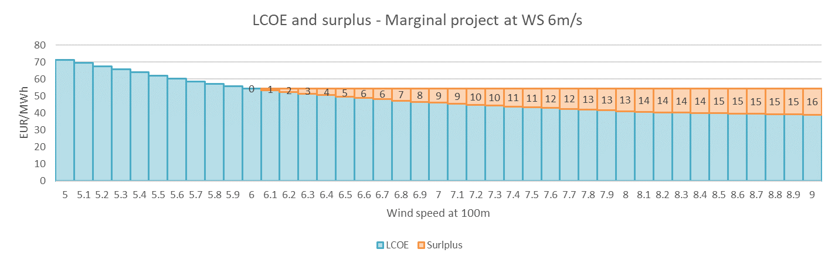

Using Equation 11, Equation 12 and Equation 13 for calculation of average subsidy, average surplus and average production, Figure 4 shows average subsidy, average surplus and electricity production per MW per year based on different marginal projects (i.e., based on scenarios with different demand/supply ratios). I.e., based on scenarios where demand equals 1, to demand equals 41 (all projects). **The average surplus is naturally highest with high demand/supply ratio (i.e., the marginal project is project with low wind speed) reaching approx. 25 EUR/MWh**, while the surplus decrease to zero when demand equals to 1 (i.e., only project with lowest LCOE/highest wind speed is chosen). The average production is conversely highest in case of low demand/supply ratio (as only projects with high production potential are chosen) and lowest in case of high demand/supply ratio (projects with low production potential are also chosen).

Figure 4; Average surplus, subsidy and production based on different demand/supply ratio

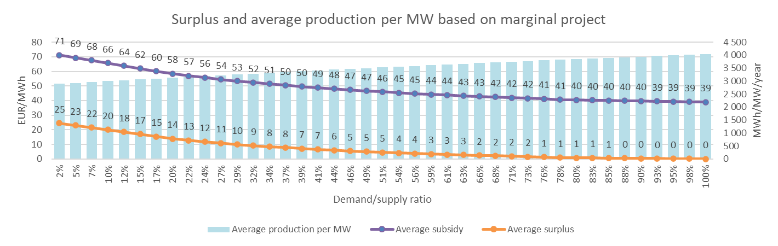

Figure 4 illustrate that the higher the difference between marginal project and weighted LCOE of other chosen projects, the higher surplus projects will reach.

# Simple case - reference yield model

The RYM is decreasing inherit differences between projects (based on production potential) thus the potential for surplus for bidders decreases. While overcorrection creates perverse incentives where projects with lower wind speeds are prioritized.

Using Equation 11, Equation 12 and Equation 13 I further show the effect of the RYM based on its applicability between 0% and 150%. Assumptions of project parameters are as follows:

*Number of projects: 41* (as in Table 4*)*

*WS100 = 5-9m/s (*uniform distribution, as in Table 4*)*

*OC = 1 (i.e., not applicable)*

*CF = percentage of range 0,79 – 1,29* (0; 50%; 99%, 101%, 150%)

The applicability of RYM is presented here in 5 scenarios; 0 where correction factor is always 1; 0.5, where correction factor applies only to 50%; values 0,99 and 1,01 which means almost perfect correction (exact value 1 would level all projects within the correction range to same minimum bid[8]) and over correction of 150%. Scenario where no reference yield applies follows the same results as presented in Figure 4.

In Figure 5 the impact of reference yield on subsidy awarded is presented. Figure 6 shows the effect on surplus of projects, while Figure 7 elaborates on the electricity production.

**The RYM reduces the average subsidy in cases where minimum bid of projects does not order projects differently than LCOE.** This is always the case if applicability of RYM is below 1. The possible saving on average subsidy ranges from few cents in case of low demand/supply ratio and gradually increasing up to around 20 EUR/MWh in case of high demand/supply ratio. In case of overcorrection the average subsidy is higher in low demand/supply scenarios (because projects with higher LCOEs are chosen) and gradually decreasing (as more projects is chosen and the difference decreases.

Figure 5; Impact of reference yield on subsidy based on demand/supply ratio – simple case



Similarly, the surplus achieved by the projects is gradually increasing with higher demand/supply ratio. Again, thy RYM is significantly decreasing the surplus. In case of perfect correction, the surplus is actually almost zero (as between corrected wind speeds of 5.36 and 8.67 there is no difference between projects).

Figure 6; Impact of reference yield on project surplus based on demand/supply ratio – simple case



The average production shows when application of RYM changes chosen projects from the optimal allocation if no RYM applies. Overcorrected scenarios show significantly lower production and are gradually increasing when demand/supply ratio equals 1.

Figure 7; Impact of reference yield on production based on demand/supply ratio – simple case



This simple case illustrates how the application of RYM decreases differences between projects and thus lowers average subsidy and surplus of projects. When thy RYM perfectly compensates the differences there is no room form profit creation. The average subsidy is decreasing up until 100% correction. However, overcorrection can change the order of projects and projects with lower LCOE might not be selected. The average subsidy should be higher, and the average production should decrease. The difference between slight under correction and slight overcorrection is very significant in this case.

# Other costs

Section 6.1 and 6.2 provided analysis of RYM based on the production potential (which RYM compensates) while disregarding other costs (which RYM does not compensate). In this section other costs will be introduced. Assumptions of project parameters are as follows:

*Number of projects: 41 (as in* Table 4*)*

*WS100 = 5-9m/s (uniform distribution, as in* Table 4*)*

*OC = 0,8 to 1,2 (randomly drawn from uniform distribution)*

*CF = percentage of range 0,79 – 1,29 (*0; 50%; 99%, 101%, 150%))

Due to the introduction of other costs, the LCOE of project is not just a function of production potential, thus projects with lower production can have lower LCOE that projects with higher production and vice versa. Other costs in combination with correction factor can change the marginal projects and thus the marginal bid. Project with higher LCOE can thus be selected over project with lower LCOE even in case of perfect RYM compensation (as it related only to the production potential). **The effect of the RYM on lowering average subsidy and surplus should thus decrease, both because different marginal projects set the clearing value of auction as well as different projects will be selected (not necessarily with lowest LCOE).**

Figure 8 shows the impact on average subsidy awarded. With introduction of other costs, the RYM provides lower subsidy only in case of higher demand/supply ratios (as the probability of projects with higher LCOE being selected decreases and the effect on reduction of project surplus increases). In case of higher demand/supply ratios the reduction on average subsidy is however still quite significant in range of around 10 EUR/MWh.

Figure 8; Impact of reference yield on subsidy based on demand/supply ratio – simple case including other costs; based on 1000 random draws



The average subsidy might be higher or lower based on the applicability of the RYM and demand/supply ratio. In Figure 9 average surplus of project is shown. The RYM up to 100% of applicability always decrease the surplus of projects (as the possibility for surplus creation comes only from differences in other costs). The RYM significantly decreases the surplus of projects with increasing demand/supply ratio.

Figure 9; Impact of reference yield on project surplus based on demand/supply ratio – simple case including other costs; based on 1000 random draws



The average production decreases with increased applicability of RYM as shown in Figure 10. Random draw of other costs in combination with the RYM significantly increase the difference between chosen projects based on the applicability of the RYM. In low demand/supply ratio cases the difference between average production is thus significant and gradually decreasing with increased demand.

Figure 10; Impact of reference yield on production based on demand/supply ratio – simple case including other costs; based on 1000 random draws



The reference model can increase or decrease the average subsidy awarded in auctions.

If the RYM does not overcompensates the differences based on production potential, the surplus of projects is on average always decreased. If the decreased surplus compensates for selection of projects with higher LCOE, then the average subsidy is lower as well. If on the other hand the decrease of surplus does not compensate for projects with higher LCOE, than the subsidy might be higher under the RYM (as seen in scenarios with low demand/supply ratios).

Since other costs significantly influence the LCOE, the precise set up of the correction is not very significant. I.e., it does not matter that much if the correction factor slightly over or under corrects.

# The model – typified distribution of supply

In previous section uniform distribution of production potential was assumed. Further I introduce 4 typified conditions of production potential:

* *Lots of bad projects*
* *Lots of good projects*
* *Lots of medium projects*
* *Lots of good and bad projects*

# Typified distributions

These typified conditions in combination with supply/demand relation should show under which conditions the RYM shows highest differences and either lower or increase the average subsidy awarded, average surplus of projects and average production.

Figure 11 shows selected wind speed cumulative probability distributions and related LCOE based only on the production potential.

Figure 11; Typified distributions of wind speed and related LCOE

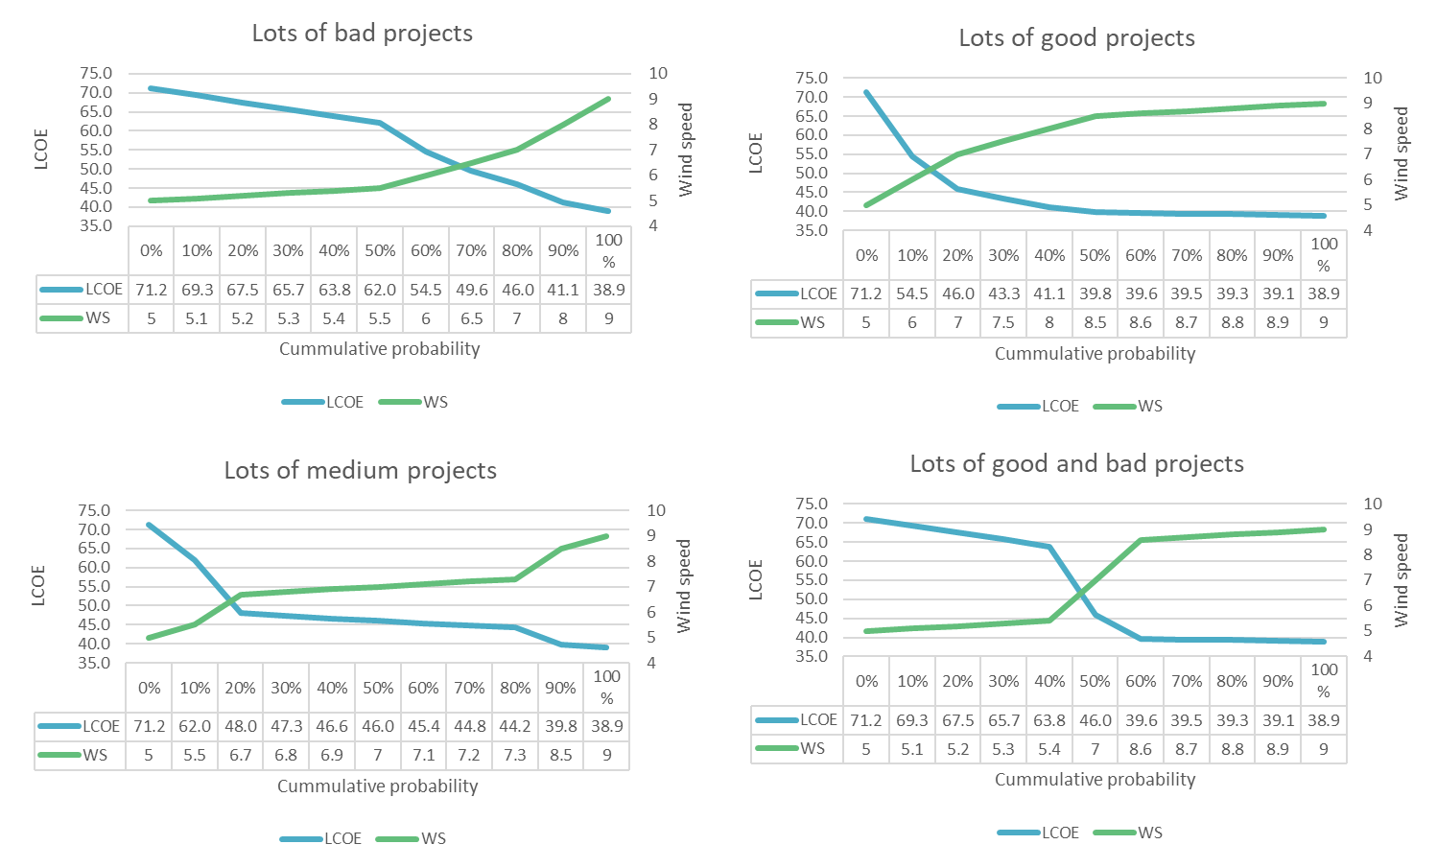

# Impact of RYM

Similarly, to Section 6; the analysis is based on production potential of 41 linearly spaced projects, however based on given typified probability density function of the production potential. Projects parameters assumptions are thus as follows:

*Number of projects: 41*

*WS100 = 5-9m/s (linearly spaced distribution based on typified distributions in* Figure 11*)*

*OC = 0,8 to 1,2 (randomly drawn from uniform distribution)*

*CF = percentage of range 0,79 – 1,29 (*0; 50%; 99%, 101%, 150%))

For simplification only differences between no RYM and application of the RYM (99%) are presented. Full results of all variants (similarly to section 6) are presented in Annex B.

The difference in average subsidy is negative under low demand /supply ratios, disregarding of the shape of the supply curve of production potential (i.e., the subsidy is higher under RYM). However, the shape of the curve significantly influences when the implementation of the RYM reduce the subsidy and to what extent mainly in between 50% and 100% demand/supply ratio.

Figure 12; Difference in average subsidy between RYM 0 and RYM 0,99; based on 1000 random draws

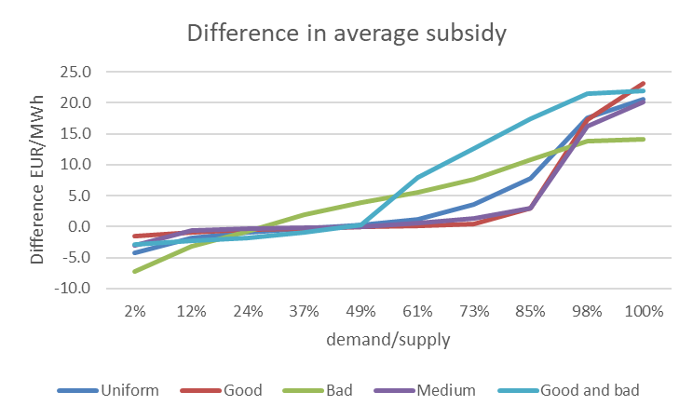

The RYM decrease the differences based on production potential, thus the higher the differences between projects the higher is the impact of the RYM on surplus reduction. Figure 13 shows the difference in average surplus of projects based on typified distributions. Again, it is to be noted that the average surplus of projects is always decreased.

Figure 13; Difference in average surplus between RYM 0 and RYM 0,99; based on 1000 random draws

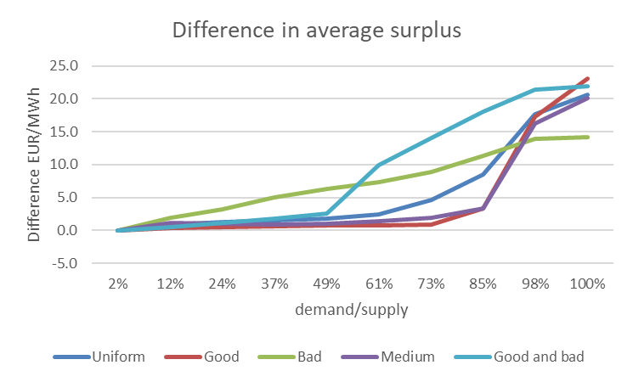

The difference between average production differs significantly based on selected probability distribution, results are presented Figure 14. Highest differences are seen in cased of significant proportion of bad production potential projects as there is a higher chance, that they may be prioritized over high production potential ones.

Figure 14; Difference in average production between RYM 0 and RYM 0,99; based on 1000 random draws

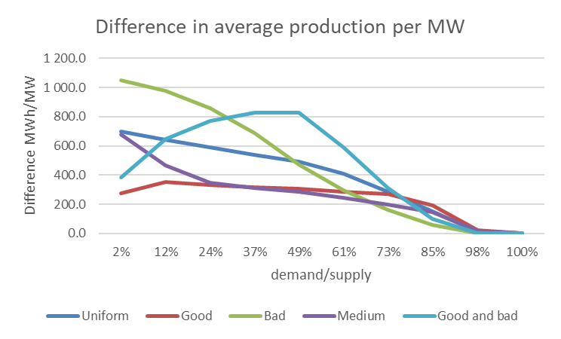

The analysis of typified production potential distribution shows that the RYM model is likely to lead to higher subsidy in scenarios with low demand/supply ratios and conversely to lower subsidies in scenarios with high demand/supply ratios. The shape of the supply curve of production potential influences the degree to what the subsidy and surplus of projects will be decreased. As the demand supply ratio increases, the surplus of projects significantly decreases (as it creates higher difference between marginal project and other selected projects). The higher the difference in production potential of chosen projects the higher the effect of the RYM.

# The model - German wind auctions

In this section I apply the model based on specific conditions of distribution of wind farms in Germany and specific supply demand conditions of past German wind auctions

# Distribution of wind speeds in Germany

As shown in Section 7, the distribution of the production potential may significantly influence the effect of the RYM. To analyse the impact of the RYM in past German auctions, in this section I elaborate on the production potential distribution of operational German wind farms.

The data with geographical location of energy plants together with the year of commencement of the operation were taken from: https://data.open-power-system-data.org/renewable_power_plants/2020-08-25. I have matched the wind potential of given wind farms to average wind speed based on geographical coordinates of wind farms. Average wind speeds were taken from gis files at https://globalwindatlas.info/downloads/gis-files.

Technological development may play an important role on the distribution of wind farms, the better the technology the less wind is needed to make the project financially viable. Further, it is reasonable to assume that sites with better wind conditions were utilized first, therefore past distribution may not be similar to future distribution.

Therefore, I further use only wind farm which commenced the operation after 2015. In the dataset this presents 5 242 wind farms. Figure 15 shows the cumulative probability distribution of wind farms in years 2015, 2016, 2017 and 2018.

Figure 15; Cumulative probability distribution of average wind speeds at 100m of wind farms build between years from 2015 to 2018

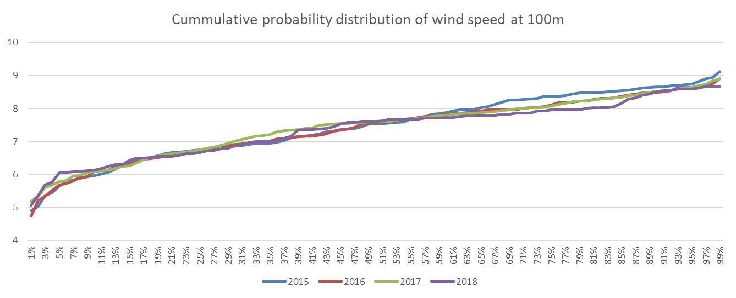

As the differences between years are relatively low, further I will use the distribution as an average of years from 2015 and 2018. Further to eliminate extremes values in the dataset I focus only on values above 1% and below 99% percentile. Figure 16 shows the probability distributions of wind speeds used for the analysis of German wind auctions. Production potential of wind farms is randomly drawn from this distribution with maximum value at 99% and minimum on 1% percentile.

Figure 16; Average cumulative probability distribution of average wind speeds at 100m of wind farms build between 2015 to 2018

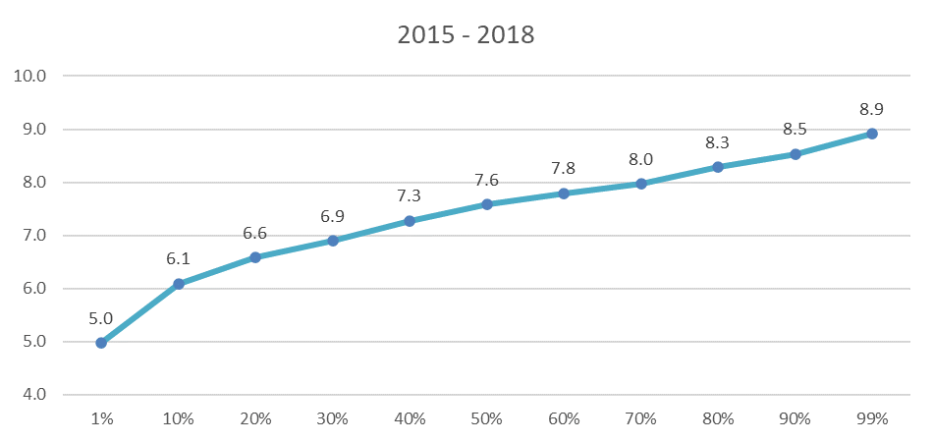

The cumulative distribution function of wind speeds is slightly concave, showing higher proportion of good projects over bad ones. Based on the results in Section 7 this suggests possible decrease of subsidy and project surplus mainly in scenarios with higher demand/supply ratios.

# Overview of auctions - demand/supply -

I analyse past German wind auction between May 2017 and September 2021. Figure 17 shows the supply and demand in MW and related demand/supply ratio. During this period only 7 auctions where oversubscribed. The other 14 auctions where undersubscribed (their demand/supply ratio was above 1).

Figure 17; Demand and supply of past German wind auctions

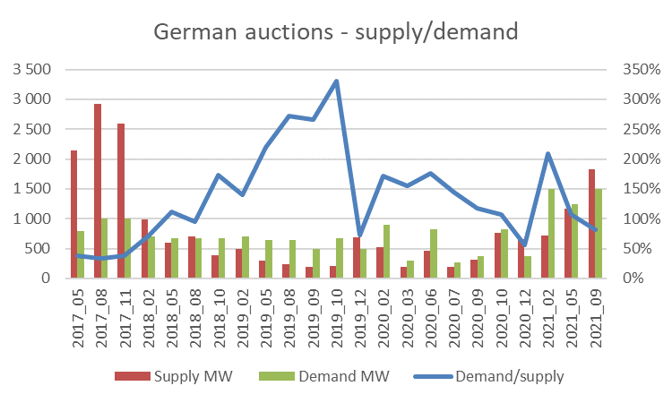

First in section 8.3 I analyse oversubscribed auctions, further in section 8.4 I provide analysis of undersubscribed auctions.

# Subscribed auctions

Projects parameters assumptions are as follows:

*Number of projects: based on past auctions (as in* Figure 17*)*

*WS100 = 5-8.9m/s (randomly drawn from distribution in* Figure 16*)*

*OC = 0,8 to 1,2 (randomly drawn from uniform distribution)*

*CF = percentage of range 0,79 – 1,29 (Table 3 and Table 4*)

Similarly, to previous sections the model shows slightly higher average subsidy awarded in auctions with low demand/supply ratios. However, the difference is not very significant in range of cents per MWh. In auctions where demand/supply ratio increase above around 50% (December 2021, February 2018, December 2019, September 2021 and August 2018), the model shows possible decrease of average subsidy. As the analysis in Section 7 with typified case of good project distribution, the model shows significant savings only in auctions with very high demand/supply ratios, where in August 2018, the model predicts almost 9 EUR/MWh saving.

Figure 18 shows the average subsidy awarded in 3 scenarios (no reference yield model 0, perfect reference yield model 1 and overcorrection 1,5.

Figure 18; Average subsidy in subscribed German auctions; 10 000 iterations

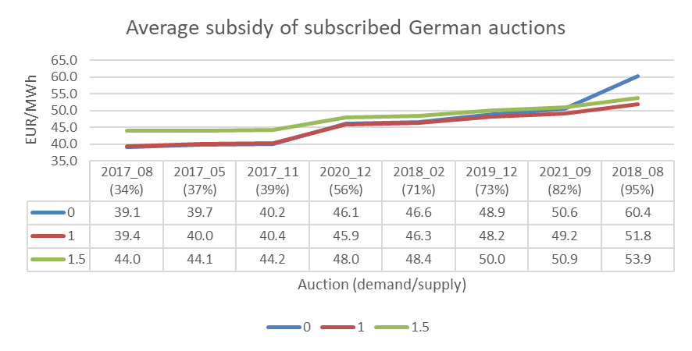

Figure 19 provides analysis of average surplus of projects, showing that the RYM decrease the surplus (bidder´s profit) achieved in all scenarios, however, significant decrease is again visible only in auction with high demand/supply ratios. Again, this result corresponds with the typified condition of mainly good projects distributions in Section 7.

Figure 19; Average surplus in subscribed German auctions; 10 000 iterations

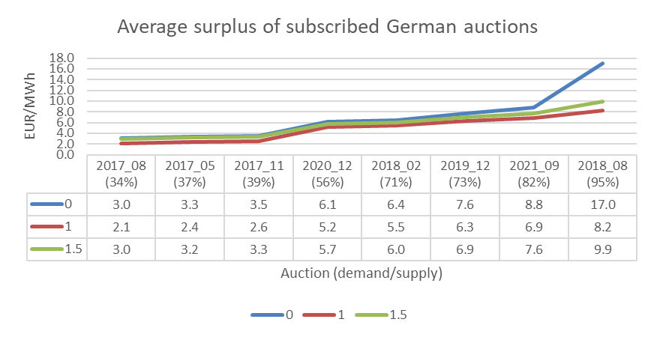

Average production however shows high differences mainly in highly oversubscribed auctions. Where the difference between RYM applications is in range of hundreds of MWh per MW. Figure 20 provides respective values.

Figure 20; Average production in subscribed German auctions; 10 000 iterations

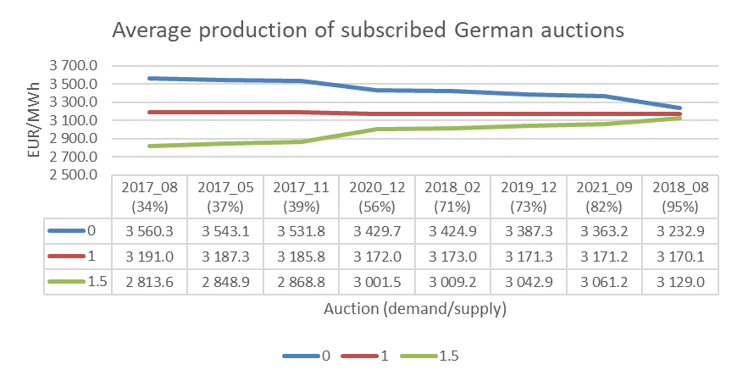

The results of the analysis show that RYM may provide savings in subsidy awarded in high demand/supply ratio auctions. Project surplus will be typically lower as well as the resulting production. However, it is important to note that auctions are performed consecutively, i.e., projects which were not awarded subsidy in previous auction will enter the subsequent ones. And since later auctions were undersubscribed, it is reasonable to assume that the distribution of production potential changes in time towards higher distribution of bad projects. As discussed in Section 7, this would lead to higher impact of the RYM even in auctions where demand/supply ratio is not extremely high.

# Under-subscribed auctions

It is problematic to model under-subscribed auctions as all the projects receive the subsidy. The correct strategy for a marginal project is to bid as much as possible (infinitely high if no limit in auction applies).

German regulation provides safeguard for this case and provides maximum possible bid in each respective auction **(in 2017 the maximum bid was 70 EUR/MWh and gradual dropping to 60 EUR/MWh in 2021).** Since the correction factor based on the RYM can increase submitted bid by up to 1,29, the maximum subsidy awarded could reach between 90 EUR/MWh (70 * 1,29) to 77,4 EUR/MWh (60 * 1,29). **However, it is not possible to predict what maximum values would be set by the regulator should the reference yield not apply (i.e., to calculate the counterfactual should the RYM not apply). As such the model setup below does not assume any maximum bid value, but rather provides case with demand/supply ratio of 1 and high supply of projects (100). I.e., project receives subsidy based on minimum bid of the worse project. This provides a safe estimation of the effect of the RYM. Should projects be able to bid even higher, the effect would increase.**

Projects parameters assumptions are thus as follows:

*Number of projects: 100*

*WS100 = 5-8.9m/s (randomly drawn from distribution in* Figure 16*)*

*OC = 0,8 to 1,2 (randomly drawn from uniform distribution)*

*CF = percentage of range 0,79 – 1,29 (Table 3 and Table 4*)

Figure 21 shows the average marginal bid (for comparison with German maximum possible values), average subsidy awarded, average surplus of projects and average production per MW. Based on the set up of the model the marginal bid is 75,9 EUR/MWh in case of no RYM and 60,9EUR/MWh in case of application of RYM. These values come from combination of low production potential and high other costs. Please note that very few extreme projects, would actually not be able to compete in later German auctions where the maximum bid was 60 EUR/MWh. The difference in subsidy as well as in surplus is 22,1 EUR/MWh. The difference in this case is equal as the reference yield model does not change the set of winners but only decreases possible surplus of projects and thus also the average subsidy. Due to this fact the effect of RYM in undersubscribed auctions is extremely high.

Figure 21; Undersubscribed auctions – possibly effect; 10 000 iterations



# Summary of German auctions

One of the main reasons for the implementation of the RYM, stated by the regulator, was to level the allocative effect of auctions, so that also wind farms on less windy south are build and the requirements for the grid infrastructure are spread across the country more evenly. Based on the limited supply of projects in most of the auctions, such allocative effect could not play a significant role. When supply of project is insufficient, the RYM can have only limited effects on the allocation or even none at all. However, effects on cost efficiency might be significant.

The analysis shows that in competitive auctions the impact of the RYM on subsidy awarded is relatively small, however in auctions with high demand/supply ratios the effect of the RYM is significant and extremely high in under subscribed auctions.

Table 5 provides a summary of estimated impact of the RYM on the subsidy awarded and surplus of projects. Note that, comparison to actual auctioned subsidies is not possible, as the regulator only makes public results of submitted bids and not data which would be adjusted by respective correction factors.

Table 5; Summary of possible impact of reference yield model on German wind auctions



The impact on surplus of projects is always equal or higher than the average subsidy. However, since most of the auctions were undersubscribed the difference in total is not very significant.

Calculating the effect on all auctions, with the estimation of the production per MW and selected amount of MW in respective auctions provides an estimate on the total effect of the RYM. The model thus shows that combined yearly difference in all auctions amount to roughly 472m EUR. Considering 20 years of support, this leads to almost 9,5b EUR during the full lifetime. As mentioned, this is not the difference that would be fully captured by the German regulator as the subsidy awarded is paid only above market prices. However, it provides an insight on the effect of regulation on the results of renewable energy auctions.

# Assumptions and limitations

There are many limitations to the presented model. The model is built on top of the assumption of link between the production potential and LCOE of the projects as assumed by the correction factor of the RYM. Further, technical assumptions are also highly simplified. As per the German regulation specific locations of the projects was not considered and thus the potential impact of grid expansion area is also not discussed. Values should therefore not be taken by their face value but rather as a trend and indicator of possible effect and their magnitude.

# Conclusion

The analysis provides overview of **possible effect of RYM on the auction environment** and in general examines auction design element which in principle levels the competition in renewable energy auctions. One could intuitively assume that if bad projects are compensated more and thus worse projects with higher LCOE are chosen in the auctions, then the average level of subsidy in auction should increase. However, considering bidding behavior, such mechanism significantly decreases the potential for **surplus** creation for better projects.

Bichler et al. (2019) concludes that the national reference yield model yields a higher allocative efficiency at the expense of a higher average remuneration per kWh, however considering bidding behavior this does not and in many cases should not be the case. As the paper shows, this relation holds only in cases with low demand/supply ratio. However, in cases where demand and supply are close, the allocation of project does not change significantly but rather only the surplus of better projects is reduced.

As such the mechanism can have significant impact on the average subsidy awarded. Based on the supply demand ratio, in past German wind auctions and assumptions of production potential distribution, such mechanism could have led to relatively low subsidy increase in auctions with low demand/supply ratio and significant reduction in auction with high demand supply ratio. However, the highest effect of the RYM can be observed in undersubscribed auctions.

One of the biggest reasons for implementing such mechanism was its allocative effect. I argue that in past German wind auctions the cost efficiency (average subsidy awarded) might have been equally important.

Interestingly RYM mechanism was introduced only in Germany. Germany had already feed in tariff system which was adjusting the level of support based on the wind conditions. Such leveling mechanism can have cost saving effect and to certain extent it can also lead back to adjusted feed in tariff if auctions are not competitive (as worse projects are receiving more than the actual maximum bid and vice versa). The reference yield model then serves again as “personal” feed in tariff based on the correction factor, as bids reach maximum possible amount and are subsequently adjusted.

If reference yield does not precisely follow the relation of wind conditions to LCOE and if it overcorrects, it might have substantial adverse effects. It can systematically promote worse projects over good ones and create possible surplus for bad projects. The average subsidy amount than again increases while the average production drop significantly. Systematic under correction (i.e., lower relation of production potential to LCOE) shows limited impact of RYM without significant adverse effects.

It is important to note that with decreased surplus for better projects, there might be also impact on future project development towards projects with lower production potential. These effects are not calculated within this model

The effect of the RYM depends on many factors, mainly the shape of the supply curve of production potential of projects, other costs distribution and demand supply ratio of auctions.

In principle the RYM levels the playing field and let the bad compete against the good. It might bring significant decrease of subsidy awarded, but it can also turn the competition upside down.

REFERENCES

Anatolitis, V., & Welisch, M. (2017). Putting renewable energy auctions into action – An agent-based model of onshore wind power auctions in Germany. Energy Policy, 110, 394–402. doi:10.1016/j.enpol.2017.08.024

Ausubel, L. M., & Cramton, P. (1998). *The Optimality of Being Efficient: Designing Auctions*. In Policy Research Working Papers. The World Bank. <https://doi.org/10.1596/1813-9450-1985>

Ausubel, L. M., Cramton, P., Pycia, M., Rostek, M., & Weretka, M. (2014). *Demand Reduction and Inefficiency in Multi-Unit Auctions*. The Review of Economic Studies, 81(4), 1366–1400. https://doi.org/10.1093/restud/rdu023

Bade, A., Käso, A., Lienert, M., Müsgens, F., Schmitz, C., Wissen, R., (2015). *Ausgestaltung eines Auktionsmodells für EE-Anlagen in Deutschland*.

Bichler, M., Grimm, V., Kretschmer, S., & Sutterer, P. (2019). Market Design for Renewable Energy Auctions: An Analysis of Alternative Auction Formats. *SSRN Electronic Journal*. <https://doi.org/10.2139/ssrn.3417550>

Binmore, K., & Klemperer, P., (2002). The Biggest Auction Ever: The Sale of the British 3G Telecom Licences. *SSRN Electronic Journal*. doi:10.2139/ssrn.297879

BMWi. (2016). *Fortgeschriebenes Eckpunktepapier zum Vorschlag des BMWi für das neue EEG,* EEG-Novelle 2016*,* Retrieved May 10, 2020, from https://www.bmwi-energiewende.de/EWD/Redaktion/EN/Newsletter/2016/04/Meldung/direkt-answers.html

CEER, (2018, June 18). *Tendering procedures for RES in Europe:State of play and first lessons learnt*, Brussels.

Corns, A., & Schotter, A. (1999). Can Affirmative Action Be Cost Effective? An Experimental Examination of Price-Preference Auctions. *American Economic Review, 89(1)*, 291–305. doi:10.1257/aer.89.1.291

Cramton P. (2009). *How best to auction natural resources*. In: Philip Daniel, Goldsworthy B, Michael K, McPherson C, editors. Handbook of oil, gas and mineral taxation. Washington, DC: IMF;.

Del Río, P., & Linares, P. (2014). *Back to the future? Rethinking auctions for renewable electricity support*. Renewable and Sustainable Energy Reviews, 35, 42–56. doi:10.1016/j.rser.2014.03.039

Del Río, P. (2017). Designing auctions for renewable electricity support. Best practices from around the world. Energy for Sustainable Development, 41, 1–13. doi:10.1016/j.esd.2017.05.006

EEG, 2017. Gesetz für den Ausbau erneuerbarer Energien (Erneuerbare-Energien-Gesetz -EEG 2017).

European Comission (2014, June 28). *Communication from the Commission — Guidelines on State aid for environmental protection and energy 2014-2020,* OJ C 200, p. 1–55

Fabra, N., Fehr, N.-H., Harbord, D., (2006). *Designing electricity auctions*. RAND J. Econ. 37, 23–46. http://dx.doi.org/10.1111/j.1756-2171.2006.tb00002.x.

Fagiani, R., & Hakvoort, R. (2014, May). Simulating the performance of market-based policies for renewable energy using learning trading agents. *11th International Conference on the European Energy Market (EEM14)*. 2014 11th International Conference on the European Energy Market (EEM). https://doi.org/10.1109/eem.2014.6861207

Gephart, M., Klessmann, C., & Wigand, F. (2017). *Renewable energy auctions – When are they (cost-)effective?* Energy & Environment, 28(1-2), 145–165. doi:10.1177/0958305x16688811

Haufe, M.-C., & Ehrhart, K.-M. (2018). *Auctions for renewable energy support – Suitability, design, and first lessons learned.* Energy Policy, 121, 217–224. doi:10.1016/j.enpol.2018.06.027

Hortay, O., & Rozner, B. P. (2019*).* Allocating renewable subsidies. *Economic Analysis and Policy*, 64, 236–247. https://doi.org/10.1016/j.eap.2019.09.003

Kitzing, L., Mitchell, C., & Morthorst, P. E. (2012). *Renewable energy policies in Europe: Converging or diverging?* Energy Policy, 51, 192–201*.* doi:10.1016/j.enpol.2012.08.064

Klemperer, P. (1999). *Auction theory. A guide to the literature*. J Econ Surv;13(3):227–86.

Klemperer, P. (2002). What Really Matters in Auction Design. *Journal of Economic Perspectives, 16(1)*, 169–189. doi:10.1257/0895330027166

Klemperer P. (2004). *Auctions: theory and practice*. Princeton University Press.

Klessmann, C., Wigand, F., Tiedemann, S., (2015). *Ausschreibungen für Erneuerbare Energien - Wissenschaftliche Empfehlungen*.

Kreiss, J., Ehrhart, K.-M., & Haufe, M.-C. (2017). Appropriate design of auctions for renewable energy support – Prequalifications and penalties. *Energy Policy, 101*, 512–520. https://doi.org/10.1016/j.enpol.2016.11.007

Krishna, V. (2010). *Auction theory*. Burlington, MA: Academic Press/Elsevier.

Luck, L., & Moser, A. (2018). *Combining Machine Learning and Multi Criteria Decision Analysis Modeling Regulatory*, Economic and Social Influences on Wind Turbine Allocation. 2018 15th International Conference on the European Energy Market (EEM). doi:10.1109/eem.2018.8470016

Matthäus, D., Schwenen, S., & Wozabal, D. (2019). Renewable Auctions: Bidding for Real Options. SSRN Electronic Journal. https://doi.org/10.2139/ssrn.3441339

McAfee, R. P., & McMillan, J. (1989). Government procurement and international trade. *Journal of International Economics, 26(3-4), 291–308*. doi:10.1016/0022-1996(89)90005-6

Menezes F, Monteiro P. (2005). *An introduction to auction theor*y. Oxford University Press.

Myerson, R.B., 1981. Optimal auction design. Math. Oper. Res. 6, 58–73. http://dx.doi.org/10.1287/moor.6.1.58.

Milgrom P. (2004). *Putting auction theory to work*. Cambridge University Press.

Piel, J.-H., Hamann, J. F. H., Koukal, A., & Breitner, M. H. (2017). Promoting the System Integration of Renewable Energies: Toward a Decision Support System for Incentivizing Spatially Diversified Deployment. *Journal of Management Information Systems, 34(4)*, 994–1022. https://doi.org/10.1080/07421222.2017.1394044

Shachat, J., & Swarthout, J. T. (2010). Procurement Auctions for Differentiated Goods. *Decision Analysis*, 7(1), 6–22. doi:10.1287/deca.1090.0159

Stetter, C., Piel, J.-H., Koukal, A., & Breitner, M. H. (2019). Enhancing Strategic Bidding Optimization for Renewable Energy Auctions: A Risk-Adequate Marginal Cost Model. In *Operations Research Proceedings* (pp. 217–223). https://doi.org/10.1007/978-3-030-18500-8_28

Wallasch, A., Luers, S., (2013). Kostensituation der Windenergie an Land in Deutschland.

# Technical assumptions regarding wind production

Calculation of wind speed from 100m to average wind speed at hub height is based on simplified equation taken from https://wind-data.ch/tools/profile.php?lng=en . Estimated hub height was taken as an average turbine in selected years as 128m. The rougness length is simplified to factor 0,1 (*agricultural land with a few buildings and 8 m high hedges seperated by approx. 500 m*).

*reference_hub = 100*

*roughness_length = 0.1*

*hub_height = 128*

*ws100_input = input average wind speed at 100m hub height*

$$wind speed at hub height=ws{100}_{input}×\frac{log⁡(\frac{hub_height )}{roughness_length})}{log⁡(\frac{reference_hub )}{roughness_length})}$$

Power curve of selected turbine Enercon E115 (selected as it is the most used turbine in Germany in given period) from wind speed 0 to wind speed 30m/s:

[0, 0,3, 48, 155, 339, 627, 1035, 1549, 2090, 2580, 2900, 3000, 3000, 3000, 3000, 3000, 3000, 3000, 3000, 3000, 3000, 3000, 3000, 3000, 3000, 0, 0, 0, 0, 0]

To estimate the production of wind turbine based on average wind speed I use Weibull distribution, with equation of cumulative probability for given wind speed calculated as:

$$cummulative_probability=1-e^{- {(\frac{ws}{ws ×1.12})}^{2}}$$

Total production is then calculated as number of hours of given wind speed during year multiplied by respective value of power curve. Further, general assumption of losses of 20% is also applied.

# Full results of different distributions of supply based on typified conditions (Section 7)

Results of average subsidy:



Results of average surplus:



Results of average production:



1. Some RES auctions, such as German PV pilot, have been performed under uniform pricing, nevertheless discriminatory pricing is much more common.
2. Exemptions are for example German or Dutch off shore wind auctions.
3. Since a specific amount of power is auctioned, the good can be defined as homogeneous (Myerson, 1981)
4. It is to be noted that costs that might differ in each bidders’ perspective such as future electricity prices forecast; other macroeconomic assumptions; cost of financing; return requirements etc. are not considered within the scope of this model (however considering subsequent resale options, they should not in theory play significant role).
5. See e.g. https://www.renewables.ninja/
6. The revenue equivalence should hold for all regular auction formats.
7. The LCOE is a measure of the average net present cost of electricity generation for a generating plant over its lifetime, i.e., how much the producers need to receive for every produced megawatt hour, in order to reach net present value of 0.
8. A solution for selecting winners would need to be implemented; therefore I have chosen slightly higher and slightly lower value to illustrate the difference.